Name : L Sai Pavan
Reg No 192472129
Course/Code : DSA0308
Date : 10/07/26

QUESTION 1: REGULAR EXPRESSION PATTERN GENERATION

Code:
import re text = """
Student Details:
Name: John Doe
Email: john.doe123@gmail.com Mobile: +91-9876543210
Password: P@ssw0rd123 Date of Birth: 15/08/2004
Register Number: 23AIML1056
Department: Artificial Intelligence and Machine Learning """

# Regular Expression Patterns
email_pattern = r'[a-zA-Z0-9._%+-]+@[a-zA-Z0-9.-]+\.[a-zA-Z]{2,}' mobile_pattern = r'\+91-\d{10}'
password_pattern = r'[A-Za-z0-9@#$%^&*!]+' dob_pattern = r'\d{2}/\d{2}/\d{4}' register_pattern = r'\d{2}[A-Z]{4}\d{4}'
print("Email ID:") print(re.findall(email_pattern, text))

print("\nMobile Number:") print(re.findall(mobile_pattern, text))

print("\nPassword:")
password = re.search(r'Password:\s*(\S+)', text) print(password.group(1))

print("\nDate of Birth:") print(re.findall(dob_pattern, text))

print("\nRegister Number:") print(re.findall(register_pattern, text))

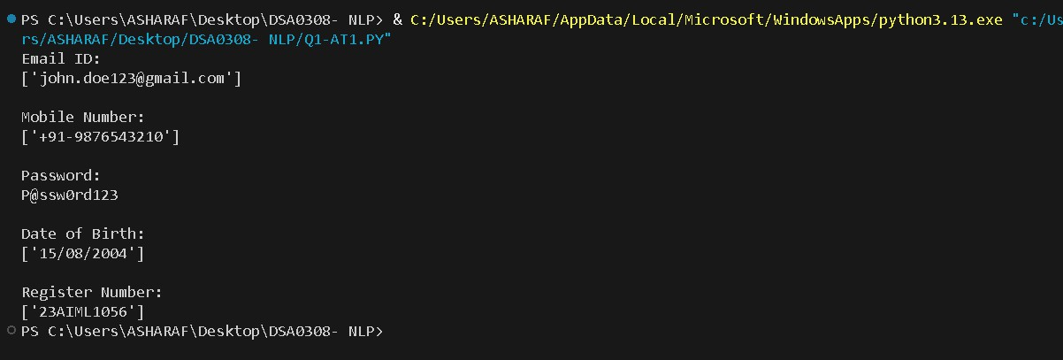

QUESTION 2: SEARCH FOR A STRING

Code:
import re paragraph = """
Artificial Intelligence (AI) is transforming industries across the world. AI is used in healthcare to assist doctors in diagnosis,
banking to detect fraud, and in education to provide personalized learning experiences.
Many companies invest heavily in AI research because AI improves efficiency and enables intelligent decision-making.
As AI continues to evolve, professionals with AI skills are in high demand. """

word = "AI"
match = re.search(word, paragraph) if match:
print("First occurrence found.")
print("Starting Position :", match.start()) print("Ending Position :", match.end()-1)

total = len(re.findall(word, paragraph)) print("Total Occurrences :", total)

else:
print("Word not found.")

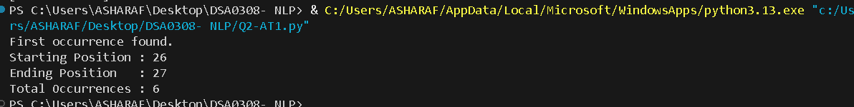

SECTION 3: SPLIT THE DOCUMENTATION INTO SENTENCES AND WORDS

Code:
import re paragraph = """
Artificial Intelligence (AI) is transforming industries across the world.
AI is used in healthcare to assist doctors in diagnosis,
banking to detect fraud, and in education to provide personalized learning experiences.
Many companies invest heavily in AI research because AI improves efficiency and enables intelligent decision-making.
As AI continues to evolve, professionals with AI skills are in high demand. """
print("Original Paragraph:\n") print(paragraph)

# Split into sentences
sentences = re.split(r'[.!?]+', paragraph)
print("\nSentences:") count = 1
for sentence in sentences: sentence = sentence.strip() if sentence:
print(f"{count}. {sentence}") count += 1

# Split into words
words = re.split(r'\s+', paragraph.strip())

print("\nWords:") print(words)
print("\nTotal Sentences :", len([s for s in sentences if s.strip()])) print("Total Words :", len(words))

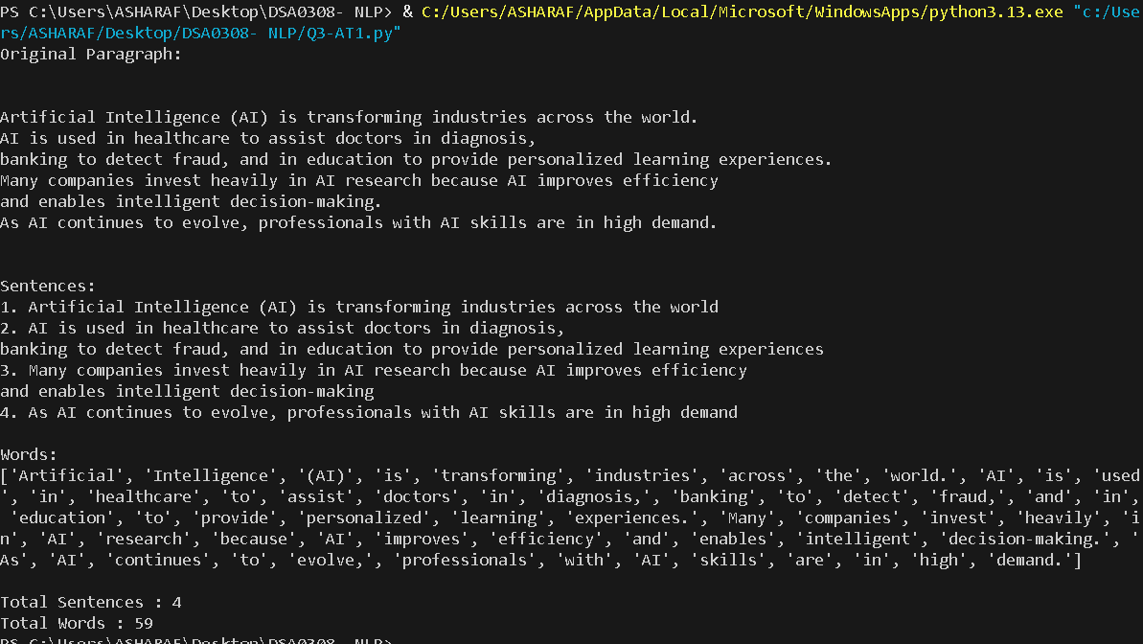

SECTION 4: EMAIL AND STRONG PASSWORD VALIDATION

Code:

import re

email = input("Enter Email ID: ") password = input("Enter Password: ")

email_pattern = r'^[A-Za-z0-9._%+-]+@[A-Za-z0-9.-]+\.(com|org|edu|in)$' password_pattern = r'^(?=.*[a-z])(?=.*[A-Z])(?=.*\d)(?=.*[@#$%^&*!]).{8,}$'
# Email Validation
if re.fullmatch(email_pattern, email): print("\nEmail ID is Valid")
else:
print("\nEmail ID is Invalid")

# Password Validation
if re.fullmatch(password_pattern, password): print("Strong Password")
else:
print("Weak Password")

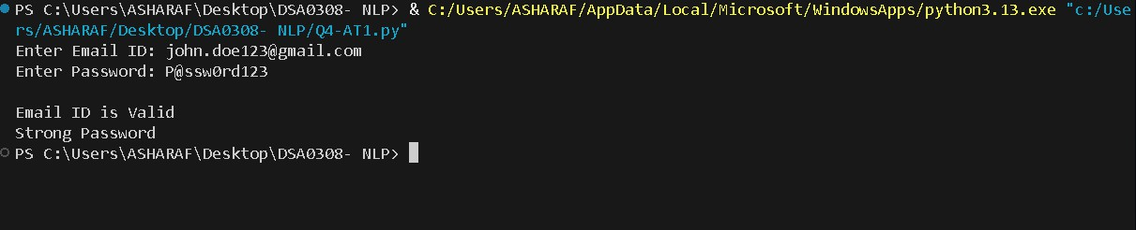

SECTION 5: COMPILE ONCE, VALIDATE MANY

Code:
import re emails = [
"john@gmail.com", "student123@yahoo.in", "invalidmail.com", "admin@college.edu", "abc@xyz", "nlp_user@gmail.com"
]

pattern = re.compile(r'^[A-Za-z0-9._%+-]+@[A-Za-z0-9.-]+\.(com|org|edu|in)$') print("Email Validation Result\n")
for email in emails:
if pattern.fullmatch(email): print(email, "-> Valid")
else:
print(email, "-> Invalid")

OUTPUT:
